**TED Talk. Taking Imagination Seriously [1]**

**SPEAKING**

1. **Discuss the following questions with your partner:**

Do you like art?   
What form of art do you like most?  
Have you ever tried drawing, painting, sculpting or something else artistic?

What is the best thing you’ve ever created?

What do you make of modern art?

1. **Look at the works of art depicted below[2]. How do they make you feel?**

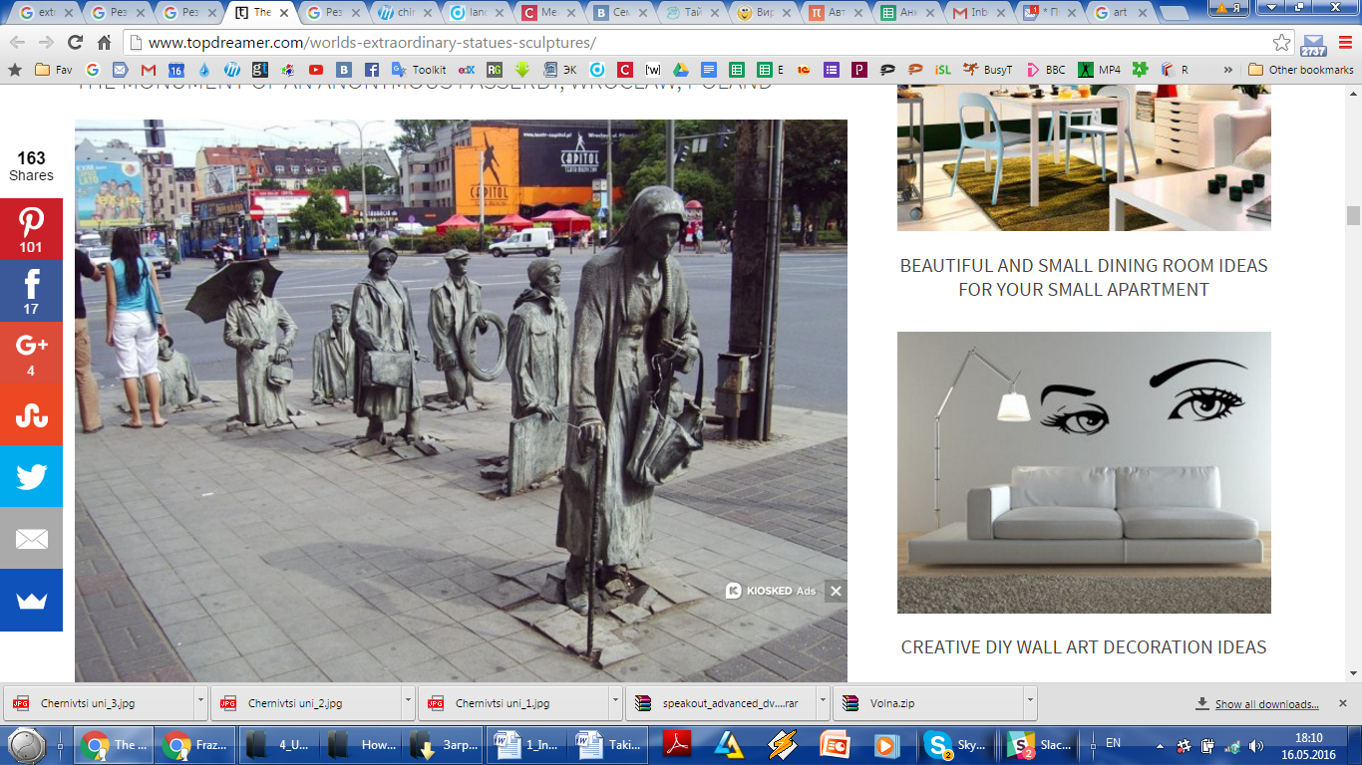 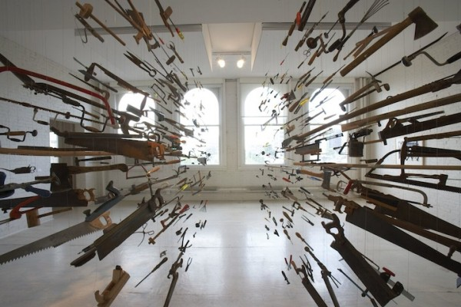

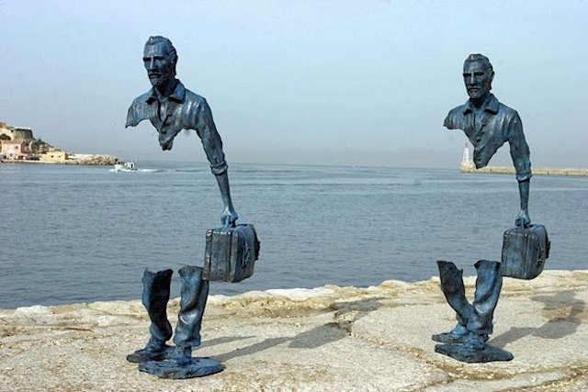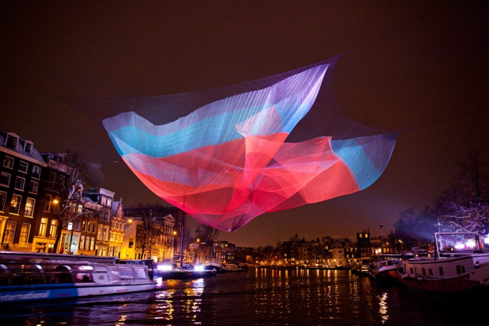

**VOCABULARY**

1. **Which of the words below can be used to describe the art in the picture?**

***impressive permanent poignant stylish billowing charming thought-provoking delicate extraordinary ephemeral striking***

1. **Choose the right definition**
2. “Solid” material is a) hard and firm; b) soft and delicate.
3. “To hoist” means a) to lift or put up smth; b) to cut or make smaller.
4. To be “mesmerized” by smth means a) to be disgusted; b) to be interested and attracted by smth.
5. “Durable” is a) smth funny and stupid; b) smth that is strong and lasts long.
6. “Hurricane” is a) an extremely strong wind; b) a very large wave.
7. Smth “porous” a) flows and can be poured like water; b) has many small holes, which water and air can pass through.
8. A “particle” is a) a very small piece of smth; b) is a member of a political party.
9. During an “earthquake” a) the ground is shaking; b) the ground is falling down a side of a mountain.
10. **Match the words with the pictures below.**

***steel lace mist fibre mesh***

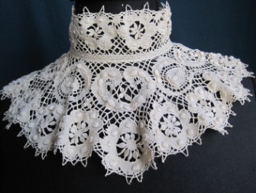 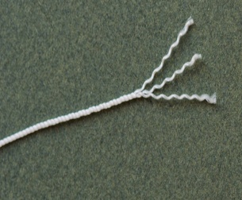 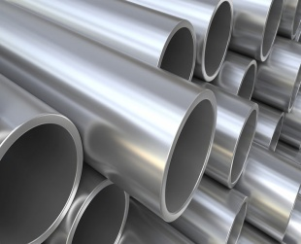 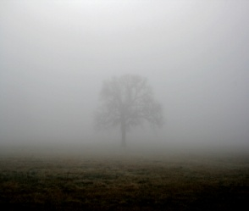 

**VIEW**

1. **Watch the video and answer the questions**
2. How did Janet Echelman (the presenter) start creating her sculptures?
3. What challenges has she had to tackle?
4. What materials has she used for her art? Tick the right options.

a ___ fiber

b ___ paper

c ___ oil

d ___ steel

e ___ foam

f ___ lace

g ___ water

h ___ china

i ___ wool

1. In which placed has created her sculptures?

a ___ Moscow

b ___ Madrid

c ___ Athens

d ___ Bejin

e ___ Warsaw

f ___ Philadelphia

g ___ Porto

h ___ Denver

i ___ New York

**SPEAKING**

1. **Describe your favourite work of art. You should say:**

* what it looks like;
* who it was created by and when;
* how it makes you feel

and explain what makes it so special for you.

1. **Discuss in small groups:**
2. Why do people become professional artists?
3. Do you think today’s artists are as good as those from hundreds of years ago?
4. Why is art so expensive? Can a work of art really be worth a million (or more) dollars?
5. What would life be like without art?

**WRITING**

1. **Write an essay about the following topic[3]:**

Advances in science and technology have made great changes to lives of ordinary people, but artists such as musicians, painters and writers are still highly valued. What can the arts tell us about life that science and technology cannot?

**Give reasons for your answer and include any relevant examples from your own knowledge or experience.**

1. <https://www.ted.com/talks/janet_echelman>

  
2. <http://www.topdreamer.com/worlds-extraordinary-statues-sculptures/>

   <http://fundamental-displays.co.za/2010/08/between/>

   <http://www.echelman.com/project/1-26-amsterdam/>
3. <http://www.dcielts.com/writing-2/essays/language-and-culture/>